|  |  |  |  |  |  |
| --- | --- | --- | --- | --- | --- |
| Design Principles | | | | | |
| Reference | Severity | +/- | Principle | Description | Sketch/Screenshot |
| 1 | 3 | + | Consistency | Most website set their calender in the right side of the website. | Figure 1 |
| 2 | 4 | - | Constraints | When there are no recording uploaded to website, the relevant button doesn’t turn gray. | Figure 2 |
| 3 | 4 | - | Consistency | Most website use their logo or logo+slogan to return the home page,but this site not. | Figure 3 |

Figure 1

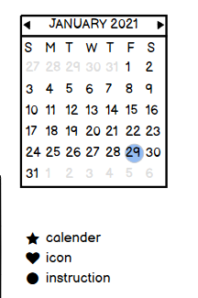

Figure 2

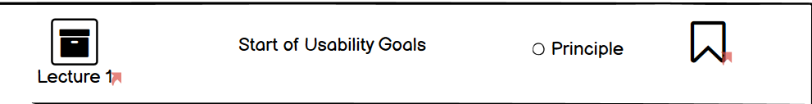

Figure 3

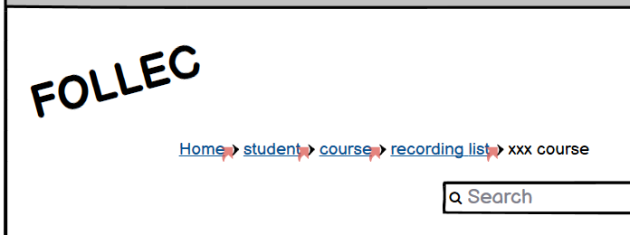

|  |  |  |  |  |  |
| --- | --- | --- | --- | --- | --- |
| Usability Goals | | | | | |
| Reference | Severity | +/- | Principle | Description | Sketch/Screenshot |
| 4 | 3 | + | Learnability | The website provide search-remind words，which make search videos easy to learn. | Figure 4 |
| 5 | 4 | - | Efficiency | Videos presented in the home page only provide the title of lecture. | Figure 5 |

Figure 4



Figure 5

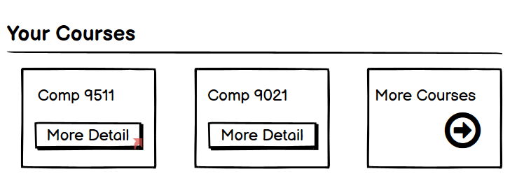

|  |  |  |  |  |  |
| --- | --- | --- | --- | --- | --- |
| Heuristics | | | | | |
| Reference | Severity | +/- | Principle | Description | Sketch/Screenshot |
| 6 | 4 | - | Flexibility and efficiency of use | The website didn’t provide shortcuts of some functions(like New Note). | Figure 6 |
| 7 | 3 | + | Match between system and the real world | In the real world,body represents somebody,and it match the system's user profile function. | Figure 7 |

Figure 6

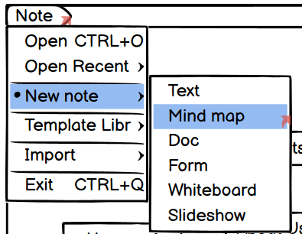

Figure 7

